Summary of lectures on the discipline « Еngineering Thermodynamics», specialty «6B07202 – Food Chemistry and Technology»,
2nd course, 2021-2022 (15 lectures)

1-Lecture
Physical chemistry, methods of its research, basic concepts and concepts. The first law of thermodynamics, its definitions, analytical formula. Hess's law, its consequences.
Thermodynamics studies the laws of transformation of energy from one form to another in various processes. Chemical thermodynamics is one of the main branches of physical chemistry - the science of applying theoretical and experimental methods of physics to solving chemical problems.
Chemical thermodynamics studies the mutual transitions of various forms of energy in the course of a chemical reaction, during phase transformations, and considers the ability of chemical systems to perform useful work.
Thermodynamics, like other branches of physics, chemistry, physical chemistry, has a certain terminology. Let's briefly consider the basic concepts and definitions of thermodynamics.
General definitions of thermodynamics
The main object of research in thermodynamics is the system.
A thermodynamic system is a body (a set of bodies) capable of (capable) of exchanging energy and (or) matter with other bodies (among themselves).
An open thermodynamic system is a thermodynamic system that can exchange matter and energy with other systems or the environment.
A closed thermodynamic system is a thermodynamic system that cannot exchange matter with other systems or with the environment, but exchanges energy.
An isolated thermodynamic system is a thermodynamic system that cannot exchange energy or matter with other systems.
An adiabatic thermodynamic system is a thermodynamic system that cannot exchange heat with other systems or the environment.
Any system is characterized by thermodynamic variables and parameters.
A thermodynamic parameter is one of the sets of thermodynamic quantities that characterize the state of a thermodynamic system. Distinguish between external and internal parameters. External parameters are macroscopic quantities determined by the relationship of external bodies in relation to a given system (volume V, strength of an electric or magnetic field). Internal parameters are determined by the interaction and state of the parts that make up a given system. These include density, pressure, internal energy. Naturally, the values ​​of the internal parameters depend on the external parameters.
An extensive thermodynamic parameter is a thermodynamic parameter proportional to the amount of matter or the mass of a given thermodynamic system. Such parameters are, for example, volume, entropy, internal energy, enthalpy, Helmholtz energy, Gibbs energy.
An intense thermodynamic parameter is a thermodynamic parameter that does not depend on the amount of matter or the mass of the thermodynamic system. Intensive thermodynamic parameters are, for example, pressure, thermodynamic temperature, concentration, molar and specific thermodynamic quantities.
Among thermodynamic variables, generalized forces (Pk) and generalized coordinates (Xk) are distinguished. Generalized forces characterize a state of equilibrium. These include pressure p, chemical potential μ, electric potential φ, surface tension σ. Generalized forces are intense properties.
Generalized coordinates are quantities that change under the action of the corresponding generalized forces. These include the volume V, the amount of substance n, charge e, area S. All generalized coordinates are extensive parameters.
The equation connecting any thermodynamic parameter (any thermodynamic property) of the system with the parameters taken as independent variables is called the equation of state.
The following states of thermodynamic systems are distinguished:
An equilibrium state is a state of a thermodynamic system, characterized under constant external conditions by the invariability of parameters in time and the absence of flows in the system. A state of a thermodynamic system that does not satisfy this definition is called a nonequilibrium state. The equilibrium state can be stable, unstable, metastable. If the independent variables are constant at each point, but there are fluxes (mass or energy) in the system, this state is called stationary.
Thermal equilibrium state - a state of a thermodynamic system in which the temperature is the same in all its parts (systems are in thermal equilibrium if there is no heat exchange between them in the absence of thermal insulation).
Standard state - the state of a thermodynamic system, in which the values ​​of some thermodynamic functions are taken as a reference point for these functions.
For individual liquid or crystalline substances at a certain temperature, their real state at a given temperature and pressure corresponding to normal thermodynamic conditions (T = 273.15 K, p = 1.01325 · 105 Pa) is taken as the standard state; The hypothetical (imaginary) state in which the gas, being at a pressure of 1.01325 · 105 Pa, obeys the laws of ideal gases, is taken as a standard state for a gas. The standard state can refer to any temperature, including absolute zero. However, most often it refers to a temperature of 25 ° C (298.15 K), since it is at this temperature that many of the most important characteristics of the processes are determined and calorimetric measurements are carried out *.
For each of the components of a solution, the standard state is usually the state of the corresponding individual substance at the same temperature and pressure and in the same phase state as the solution (symmetric standard state normalization method), or the state of the component in an infinitely dilute solution (non-symmetric normalization method).
There are other ways to select standard states.
Definitions of transition functions and state functions of thermodynamic systems
Heat (Q) is the energy that a body receives or loses in the process of heat exchange with the environment; energy is transferred through collisions of molecules, i.e. at the microscopic level, at the border of the contact of a more heated body with a less heated one.
Work (A) is the energy transferred from one body to another, not associated with the transfer of heat and (or) matter. Work in the generalized thermodynamic sense is any macrophysical form of energy transfer. When performing work in thermodynamics, the state of macroscopic bodies changes: their volume and temperature.
Heat and work are functions of the transition (process), their values ​​depend on the path along which the system changes.
The state functions depend only on the state of the system and do not depend on the path along which this state is obtained. These include:
Entropy is a function of the state of a thermodynamic system, determined by the fact that its differential (dS) in an elementary equilibrium (reversible) process is equal to the ratio of an infinitely small amount of heat (Q) imparted to the system to the thermodynamic temperature (T) of the system
Internal energy is a function of the state of a closed thermodynamic system, determined by the fact that its increment in any process taking place in this system is equal to the sum of the heat imparted to the system and the work done on it:
Internal energy is a characteristic function if entropy and volume are independent parameters.
A characteristic function is a function of the state of a thermodynamic system, characterized by the fact that by means of this function and its derivatives with respect to the corresponding independent variables, all thermodynamic properties of the system can be expressed in an explicit form.
Enthalpy is a function of the state of a thermodynamic system, equal to the sum of the internal energy and the product of volume and pressure:

Enthalpy is a characteristic function if entropy and pressure are independent parameters.
Helmholtz energy is a function of the state of a thermodynamic system, equal to the difference between the internal energy and the product of thermodynamic temperature and entropy:
Helmholtz energy is a characteristic function if volume and thermodynamic temperature are independent parameters.
Gibbs energy is a function of the state of a thermodynamic system, equal to the difference between the enthalpy and the product of thermodynamic temperature and entropy:

Gibbs energy is a characteristic function if pressure and thermodynamic temperature are independent parameters.
Chemical potential (μ) is a partial derivative of the characteristic function by the amount of substance of a component with constant corresponding independent parameters and masses of the remaining components

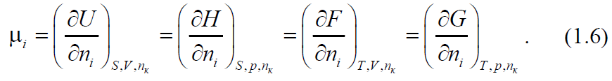

Definitions of thermodynamic processes
A thermodynamic process is a change in the state of a thermodynamic system, characterized by a change in its parameters.
An equilibrium process is a thermodynamic process that is a continuous sequence of equilibrium states.
A quasi-equilibrium process is characterized by an infinitely slow transition of the system from one state to another due to the negligible difference between the opposing external influences on the system and the internal counteracting forces.
A nonequilibrium process is a thermodynamic process that is a sequence of states, among which not all are equilibrium states.
A reversible process is a thermodynamic process after which the system and the systems interacting with it (environment) can return to their initial state without any changes in the systems and the environment.
A reversible change is a change that can be made in the opposite direction with an infinitely small change in a variable.
An irreversible process is a thermodynamic process after which the system and the systems interacting with it (environment) cannot return to their initial state without the occurrence of residual changes in the system or the environment.
A quasi-static process in thermodynamics is an idealized process consisting of equilibrium states continuously following each other.
Depending on the process conditions, the following are distinguished:
Isobaric process is a thermodynamic process that occurs at constant pressure in the system.
Isochoric process is a thermodynamic process that occurs at a constant volume of the system.
Isothermal (isothermal) process is a thermodynamic process that occurs at a constant temperature of the system.
An adiabatic process is a thermodynamic process in which the system does not exchange heat with the environment and in which the only interaction between the system and the environment is the interaction that performs the work.
An equilibrium adiabatic process is an isentropic process, i.e. occurring at constant entropy of the system.
A polytropic process is a thermodynamic process that satisfies the ratio - a constant value.
pV ^{n}  const, where n is the polytropic exponent
Isoenthalpy process is a thermodynamic process that occurs at constant enthalpy.
Phase transition is a thermodynamic process of the transition of a substance from one phase to another.
Phase transitions of the first order are transitions from one phase to another, accompanied by thermal effects and a change in the specific volume and characterized by abrupt changes in the first derivatives of the chemical potential (evaporation, melting, processes of the S_{romb} → S_{mon} type, etc.).
Phase transitions of the second kind are such transitions of a substance from one phase to another, in which the first derivatives of the chemical potential are continuous, but the second derivatives undergo jumps. Such transitions occur without a thermal effect and a change in the specific volume, but with a change in the heat capacity, compressibility, and thermal expansion coefficient (for example, transitions of liquid helium to a superfluid state, transitions in ferroelectrics, changes in ferromagnetic properties, etc.).
Thermal Effects Definitions
The thermal effect of a chemical reaction is the heat absorbed (released) as a result of the chemical transformation of the starting materials into reaction products in quantities corresponding to the chemical reaction equation under the following conditions:
- the only possible work in this case is work against the pressure of the environment;
- both the starting materials and the reaction products have the same temperature.
At constant volume, this is the isochoric thermal effect 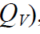,
at constant pressure - isobaric thermal effect 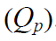.
Heat of formation 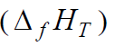- isobaric thermal effect chemical the reaction of the formation of a given chemical compound from simple substances, referred to 1 mol or 1 kg of this compound. The heat of formation of 1 mol of a chemical compound, characterized by the fact that the initial substances and products of the chemical reaction are in standard states, is called the standard heat of formation, or the standard enthalpy of formation 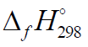
The heat of combustion 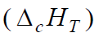 is the heat effect of the oxidation reaction by oxygen of 1 mol of a chemical compound (at constant pressure) with the formation of combustion products. CO₂ (g), H₂O (g), N₂ (g), SO₂ (g) and HCl (g) are taken as combustion products of elements C, H, N, S and Cl.
Heat capacity - a derivative of the amount of heat by temperature in any thermodynamic process
Definitions of chemical thermodynamics
An exothermic reaction is a chemical reaction accompanied by the release of heat.
An endothermic reaction is a chemical reaction that absorbs heat.
Chemical equilibrium is a thermodynamic equilibrium that is established in a chemically reacting system.
Homogeneous chemical equilibrium - chemical equilibrium in a single phase system.
Heterogeneous chemical equilibrium - chemical equilibrium in a system of two or more phases.

2-Lecture
Heat capacity, its dependence on various factors. Mayer's equation. Temperature dependence of the thermal effect of a chemical reaction, Kirchhoff's equation.

The first law of thermodynamics is one of the forms the law of conservation of energy, established by Hess (1840), Mayer (1842), Joule (1842) and Helmholtz (1847), according to which energy does not disappear and does not arise again from nothing during the process, it can only pass from one form to another into strictly equivalent quantities.
The following formulations of the first law of thermodynamics follow from the law of conservation of energy as applied to processes associated with transformations of heat and work:
1. The heat absorbed by the system (Q) is spent to increase the internal energy of the system ($∆$U) and to perform work by it (A), i.e.
2. Perpetual motion machine (perpetuum mobile) of the first kind is impossible, i.e. it is impossible to create such a mechanism (machine) that would make it possible to get work without spending an appropriate amount of energy on it.
3. The internal energy of an isolated system is constant.
Relation (3.1) should be considered as a mathematical expression of the first law of thermodynamics *.
This law is universal. A number of consequences arising from it are of great importance for solving various problems: calculating the energy (heat) balance, calculating the thermal effects of various processes. By means of such calculations, it is sometimes possible to calculate quantities that are not amenable to direct measurement.
Internal energy is that part of the energy of the system that is not associated with the kinetic energy of its movement as a whole and its presence in an external force field. Internal energy consists of the energy of thermal excitation (the energy of translational, rotational, vibrational motion of molecules, the energy of their electronic excitation), the energy of chemical bonds and the energy of non-covalent interactions. The internal energy of a substance at a given temperature and pressure does not depend on whether the body is at rest or in motion. Internal energy is an extensive quantity. Only a change in internal energy that accompanies some change in the state of the system has a physical meaning.
Internal energy is a continuous, unambiguous and final function of the state of the system *.
Unlike internal energy, heat and work are not functions of state; their values ​​depend on the path of the process.
Work A is an ordered form of energy transfer from one body to another, associated with the movement of masses, covering very large numbers of molecules (i.e. macroscopic masses), under the action of any forces. There are different types of work. An infinitesimal work 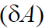of any kind can be represented as the product of the generalized force 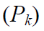and the change in the generalized coordinate 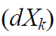. The concept of "generalized" means that forces and coordinates can have arbitrary dimensions, but their product has the dimension of energy.
For example, the work of lifting the body in the gravitational field
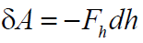, where 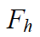 is the force of gravity; 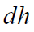 - the infinitely small height to which the body is lifted. Surface tension work
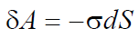, where 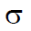 - surface tension; dS - infinitesimal increase in surface area between phases.
Gas expansion work - work against external pressure 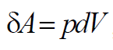, where p -
external pressure; dV - infinitesimal increase in volume.
The sum of all types of work, with the exception of mechanical work, is called useful (non-mechanical) work.
With an infinitely small change in the state of the system, all energy effects are also infinitely small. In this case, the mathematical expression of the first law of thermodynamics will have the form
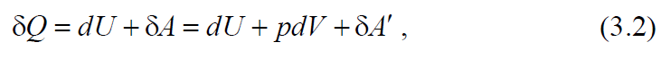
where dU is the total differential of the internal energy of the system (since the change in this function does not depend on the path of the process); 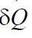 and
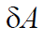 - infinitely small amounts of heat and work; pdV - elementary work performed by the system against external pressure (expansion work); 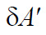 - the sum of all other types of elementary work (electrical, magnetic, etc.).
Very often during thermodynamic processes the only work is the work of expansion. In this case, equation (3.2) takes the form
Heat Q is a disordered form of energy transfer from a more heated body to a less heated one, associated with the chaotic movement of particles, not associated with the transfer of matter and the performance of work.
The dependence of heat on thermodynamic variables can be expressed using the differential expression of the first law of thermodynamics (3.3), considering the internal energy as a function of temperature and volume:
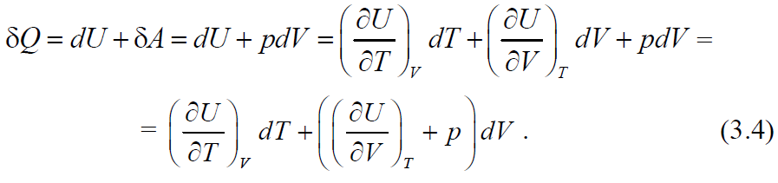
The partial derivatives included in equation (3.4) are called the caloric coefficients of the system. They characterize the specific heat of the system at constant volume 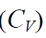:
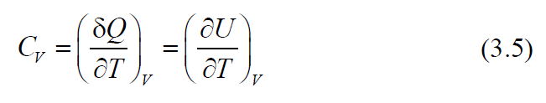
and latent heat of isothermal expansion (l):
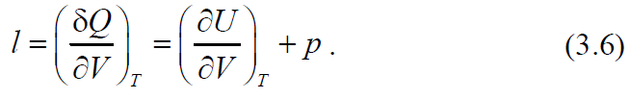
In addition to these partial derivatives, the caloric coefficients of the system also include other partial derivatives of heat with respect to the variables T, V, and p. The most important of these is the isobaric heat capacity (C_{p}):
The processes in which the system participates can occur under various conditions: processes occurring at constant volume are called isochoric, at constant pressure - isobaric, at constant temperature - isothermal. Processes in which the system does not exchange heat with the environment are called adiabatic.
Let us consider the equation of the first law of thermodynamics of the form (3.3) as applied to the listed processes.

Isochoric process
When the state of the system changes, the volume remains constant (V = const), therefore, 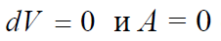, therefore, equation (3.3) has the form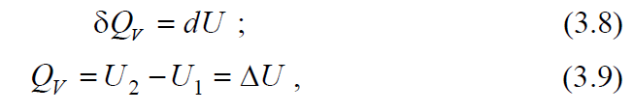
those. the amount of heat received by the system during the isochoric process is completely used to increase the internal energy.
Integration of equation (3.5) with 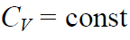 leads to the relation
where 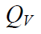 is the heat absorbed by the system during the isochoric process; 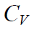 is the molar heat capacity at constant volume.
According to the Gay-Lussac law
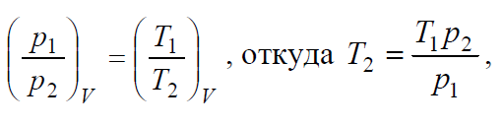
substituting this relation into equation (3.10), we obtain
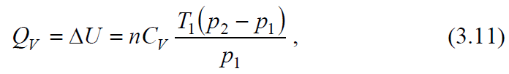
where n is the number of moles of the substance; p₁ and p₂ are the initial and final gas pressures, respectively.
Isobaric process
With an isobaric process (p = const), the expansion work 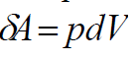
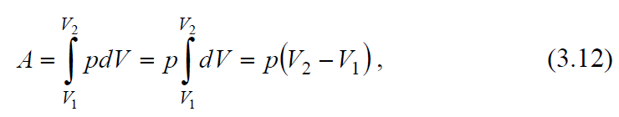
where V₁, V₂ are the initial and final volumes of the system.
Equation (3.12) combined with the equation of state for an ideal gas 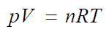 leads to the relation

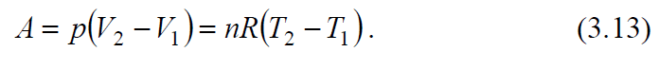
The amount of heat absorbed by the gas during the isobaric process, based on (3.7), at 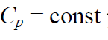

where 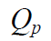 is the heat absorbed by the system during the isobaric process; 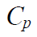 - molar heat capacity at constant pressure.
According to the Gay-Lussac law

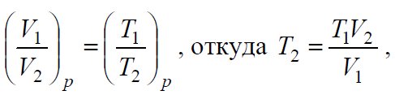
substituting the last relation into equation (3.14), we obtain
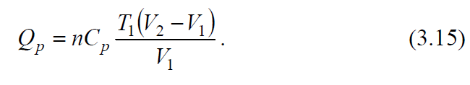
For an isobaric process, equation (3.3) using the equation (3.12) can be transformed to the form
those for this process, not internal energy is used as an energy characteristic, but another function of state - enthalpy H:
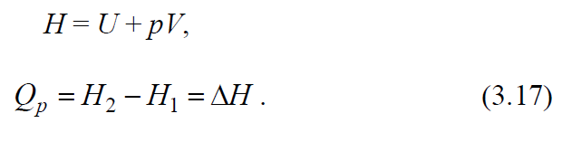
The change in enthalpy depends only on the initial and final state of the system.
Based on (3.16), (3.17), and (3.9), we obtain

Isothermal process
With isothermal (T = const) expansion of an ideal gas, the change in the internal energy is equal to zero 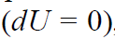, therefore, in accordance with equation (3.3), 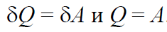
The work of 1 mol of gas can be calculated by the equation
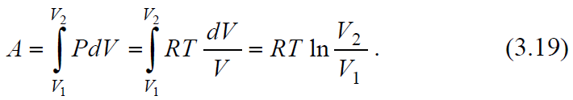
For n mol of gas
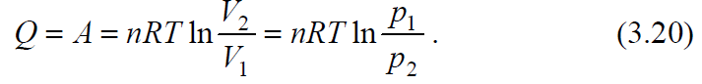

Adiabatic process
In the case of adiabatic expansion of an ideal gas (there is no heat exchange) 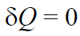, Eq. (3.3) takes the form
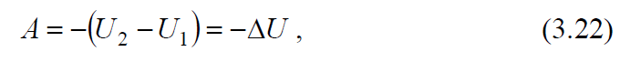
those. work is done by the system due to the loss of its internal energy.
With 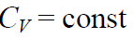in accordance with (3.10)
Taking into account the adiabatic equation 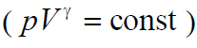, the work of the adiabatic process can also be calculated by the equations:
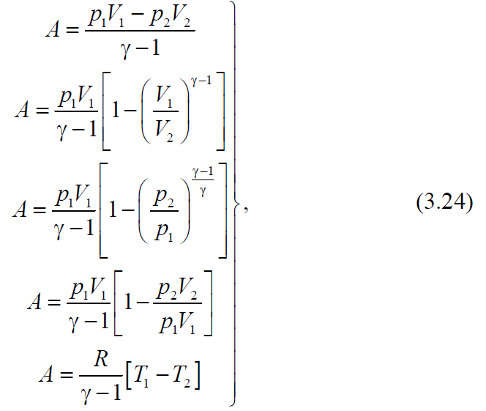
where p₁, V₁, T₁ - pressure, volume and temperature in the initial state; p₂, V₂,T₂ - pressure, volume and temperature in the final state; 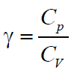.
Pressure, volume and temperature at the beginning and end of the adiabatic process are related by the following equations
The molar heat capacity of an ideal gas at a constant volume without taking into account the energy of vibrational motion, that is, at relatively low temperatures:
- for monatomic molecules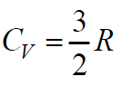
- for diatomic and linear triatomic molecules 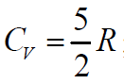;
- for nonlinear triatomic and polyatomic molecules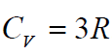
Ratio between C_{p} and C_{V}
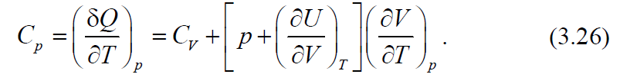
On the basis of Joule's experiments, it was found that during the isothermal expansion of an ideal gas, its internal
the energy does not depend on the volume, i.e., 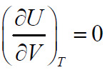
In isothermal processes with the participation of an ideal gas, the internal energy does not change and
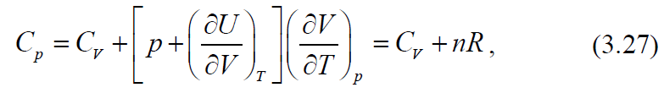
or for 1 mole of ideal gas
Equation (3.28) is called Mayer's formula. According to (3.28), at constant С_{p} in the same temperature range, the value of C_{V} should also be constant. For monatomic gases this is carried out within very wide limits, and for diatomic gases - only in the range from 100 to 1000 K. The difference is associated with the manifestation of quantum laws.
For real gases 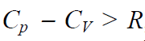, the higher the gas pressure, the more the difference in heat capacities will differ from R.
Table 3.1 shows expressions for work, heat and changes in internal energy in four basic processes with ideal gases.
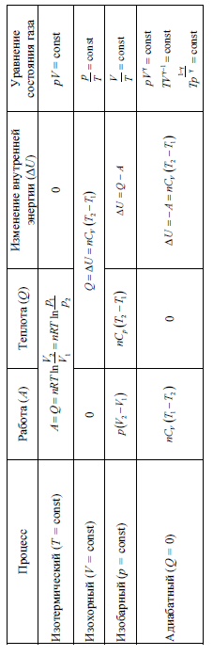

Lecture 3
Application of the first law of thermodynamics to various processes involving ideal gases.

Thermochemistry. Heat effect of the process. Hess's law
Thermochemistry is a branch of chemical thermodynamics that studies the thermal effects of chemical reactions and processes.
The processes in which heat is released are called exothermic, and the processes in which heat is absorbed are called endothermic.
The thermal effect of a chemical reaction is a measure of the change in energy storage as a result of a given process; it is determined by the sum of the heat released (absorbed) during the reaction and the perfect external work (expressed in the same thermal units) when the molar quantities of a substance * react with each other.
Usually chemical reactions are carried out at constant pressure or constant volume. If during their course there are no other types of work, except for the work of expansion of the system, then at constant pressure, based on (3.17) and (3.18),
Qp  dH , Qp  H , (3.29)
and at constant volume, according to (3.8) and (3.9),
QV  dU , QV  U . (3.30)
The pressure (volume) of the system must be constant from the beginning of the process to its completion, only in this case equations (3.29) and (3.30) will be valid and the heat will be a function of the state. For ideal gas mixtures, the internal energy does not depend on either volume or pressure (U_{V} = U_{p}), and for real gas systems at low pressures, we can take U_{V} ≈ U_{p}.
The heat Q_{p}, expressed by relation (3.29), is called the heat effect of the reaction at constant pressure, respectively, the heat Q_{V} according to (3.30)  at a constant volume.
The thermal effect of a chemical reaction is understood as the amount of heat that is released or absorbed during a chemical reaction under the following conditions:
1) the process takes place at constant pressure or volume;
2) no work is performed in the system, except for the work of expanding the system;
3) the temperature of the reaction products is equal to the temperature of the starting materials.
Under these conditions, the thermal effect becomes a value that depends only on the nature of the ongoing chemical reaction.
Equalities (3.29) and (3.30) as applied to chemical reactions constitute the essence of Hess's law (1840): the thermal effect of a reaction proceeding at constant pressure or constant volume does not depend on the path of the process (intermediate stages), but is determined only by the initial and the final states of the system, i.e. states of initial substances and reaction products.
In other words, the thermal effect of a chemical reaction is equal to a change in the state function: the thermal effect of a process at constant pressure is equal to a change in the enthalpy of the system, and at a constant volume, it is equal to a change in internal energy.
If the reaction proceeds in solution or in the solid phase, where the volume change is insignificant, then
H = U + pV  U. (3.31)
If ideal gases are involved in the reaction, then at constant temperature
H = U + pV = U + nRT, (3.32)
where n is the change in the number of moles of gaseous substances taking part in the reaction:
n  nпрод  nисх , (3.33)
(г) (г)
where  nprod is the number of moles of gaseous reaction products (according to the reaction equation), ref (g)
- the number of moles of gaseous starting materials (according to the reaction equation).
Fourth corollary. The heat effect of the reaction is equal to the difference between the sum of the heats of formation of the reaction products and the sum of the heats of formation of the starting materials:
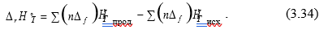
Fifth corollary. The heat effect of the reaction is equal to the difference
between the sum of the heats of combustion of the starting materials and the sum of heats of combustion of the reaction products
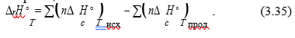
3.3. Heat capacity
The heat capacity of the system is understood as the amount of heat required to heat a unit of the amount of a substance by one degree.
There are several types of heat capacities, the criteria for dividing into which are:
- units of the amount of substance;
- the nature of the thermodynamic process;
- the value of the temperature interval.
Depending on the unit of the amount of substance - 1 kg, 1 m³ and
1 mol - there are three types of heat capacities:
- specific, referred to 1 kg of mass (Sud, J / (kg·K));
- volumetric, referred to 1 m³ of gas under normal physical conditions (Sb, J / (m³·K));
- molar, referred to 1 mol (Сm, J / (mol·K)).
Depending on the nature of the thermodynamic process, isobaric Ср and isochoric СV heat capacities are distinguished, since usually experimental measurements of heat capacities are carried out at р = const and V = const, respectively. The relationship between Cp and CV is given by equation (3.26), and for isothermal processes with the participation of 1 mole of an ideal gas, by Mayer's formula (3.28).
Depending on the size of the temperature interval, there are
average and true heat capacity.
The average heat capacity of a homogeneous system corresponding to a finite temperature range is determined by the ratio
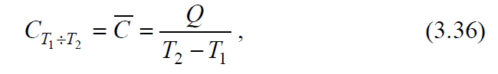
where Q is the amount of heat, due to the receipt (return) of which the temperature of the system rises (falls) from T₁ to T₂.
In this case, it is assumed that heating (cooling) does not lead either to a phase transformation or to a change in the composition of the system.
The true heat capacity is understood as the heat capacity corresponding to an infinitesimal change in temperature (dT), i.e.
where Q – is an infinitesimal amount of heat.
Average and true heat capacities are related by the equation
The narrower the interval (T₂ - T₁), the closer the average heat capacity to the true one.
To determine the true heat capacity from the average, use the ratio
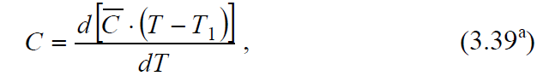
if T₁ = 0 K, then the average heat capacity should be multiplied by the temperature T and differentiated by temperature, i.e. use the equation
Dependence of heat capacity on temperature. The heat capacity of a substance can be considered independent of temperature only in a relatively narrow temperature range. Heat capacity is a complex function of temperature. Usually this dependence is expressed using a power series, the coefficients of which are determined empirically:
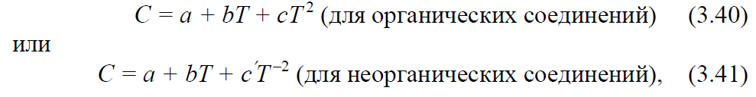
where a, b, c, c, are empirical coefficients valid for a given temperature range.
The coefficients of such series are placed in special tables indicating the temperature range in which the corresponding series gives a good approximation.
The amount of heat spent on heating n mol of a substance from T₁ to T₂ is determined from the ratios:
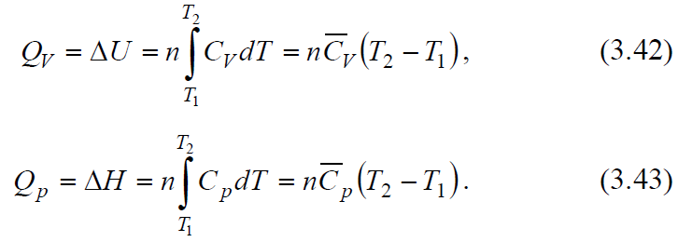
Taking into account that the heat capacity is a function of temperature and is described by the power series (3.40), integrating expression (3.43), we obtain an expression for calculating the amount of heat
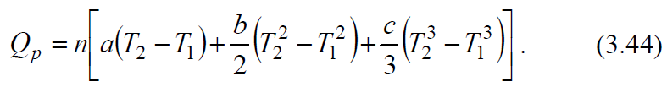
If the specific heat is described by the power series (3.41), then
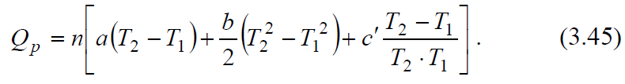
Having data on the dependence of the heat capacity of an individual substance on temperature, it is possible to calculate for it, using equation (3.44) or (3.45), the change in enthalpy upon heating in the temperature range from T₁ to T₂.
Kirchhoff's equations
The equations expressing the dependence of the thermal effect of a chemical reaction on temperature were derived by Kirchhoff in 1858. Kirchhoff's equations in differential form:
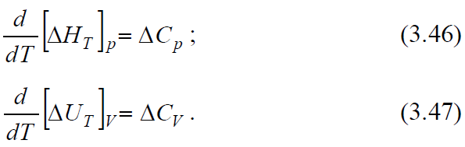
It follows from the Kirchhoff equations that the temperature coefficient of the heat effect of the process is equal to the change in the heat capacity of the system that occurs as a result of the process.
Equation (3.46) is strictly valid only under the condition that the pressure above each of the components at the desired temperature will be the same as at the given temperature. From (3.46) it follows that the sensitivity of ΔH to a change in T is determined by the absolute value of ΔCр, and the sign of the temperature coefficient of the thermal effect is determined by the sign of ΔCр.
At Ср> 0, the thermal effect of the reaction increases with increasing temperature, at Ср <0 it decreases, at Ср = 0 it does not depend on temperature. It should be noted that the ΔСр sign is also associated with the choice of the sign of thermal effects.
The nature of the change in H with a change in temperature is due to the nature of the change in Cр with T. 3.1 schematically depicts all possible cases, except those when ΔH is a linear function of temperature. The extremum on the ΔH = f (T) curves is observed relatively rarely, since usually the temperature ranges are not very large. However, the very possibility of the appearance of an extremum serves as an indication of the inadmissibility of significant extrapolation of the temperature dependence of the thermal effect beyond the experimental data or guaranteed accuracy of the formulas.
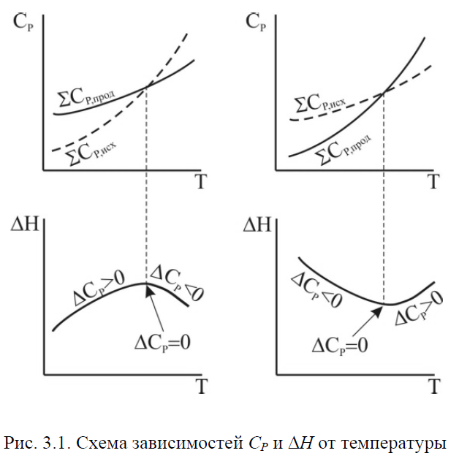
To calculate the thermal effect of the process at p = const, it is necessary to integrate equation (3.46) in the temperature range from T₁ to T₂, i.e.
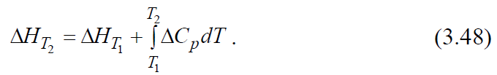
A similar expression is obtained for the heat effect of the process at constant volume (from equation (3.47)):
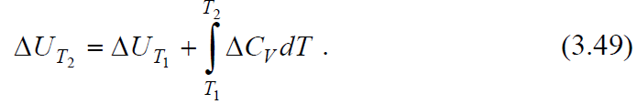
When using equations (3.48) and (3.49), it should be borne in mind that in the temperature range from T₁ to T₂ there should be no phase transitions of the substances participating in the reaction.
Thus, knowing the heat effect of the reaction at one temperature T₁, one can find it at another temperature T₂, if the heat capacities and their dependence on temperature in this temperature range are known.
When calculating ΔH, several degrees of approximation can be considered:
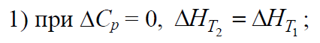
3) if the dependence of the heat capacity of each substance is expressed in the form of power series (3.36) and (3.37), then for the reaction
is also expressed as a series
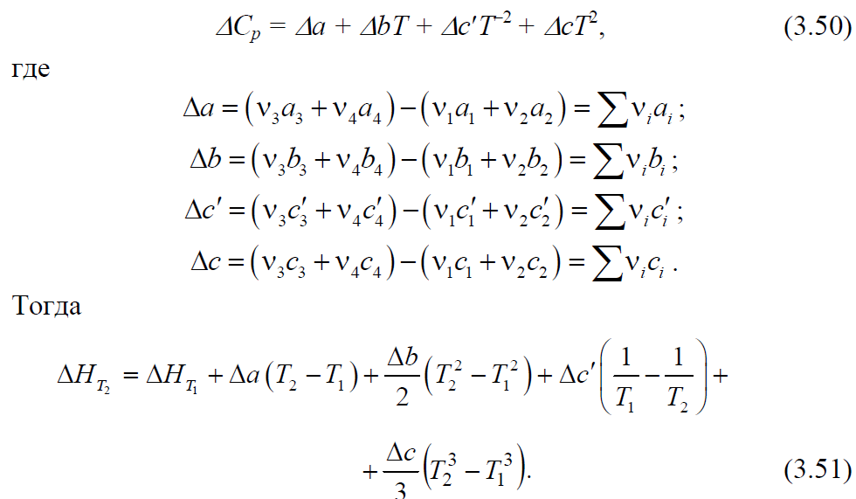
ΔU is calculated similarly.

Lecture 4
The second law of thermodynamics, its concepts. Carnot cycle and Carnot's principle. Efficiency of an ideal heat engine. Entropy.
The conclusion about the insufficiency of the first law of thermodynamics to determine the direction and limit of the course of processes led to the establishment of the second law of thermodynamics. Many formulations of the second law, equivalent to each other, are known. One of the first is the Carnot – Clausius theorem, which proves that the efficiency (η) of a heat engine when operating according to a quasi-static Carnot cycle and the highest possible efficiency is a heat engine, regardless of the type of the working body, is expressed by the ratio
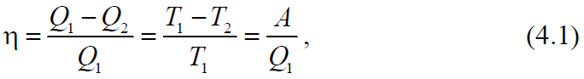
where Q₁ is the amount of heat imparted at the temperature T₁ to the working fluid from the heat source, Q₂ is the amount of heat given by the working fluid at the temperature T₂ to the refrigerator, A is the work done by the system.
Carnot's formulation: to convert heat into work, you must have two sources of heat of different temperatures.
Clausius' postulate: a process is impossible, the only result of which would be the transfer of heat from a colder body to a hotter one (this process is called the Clausius process).
Thomson's (Kelvin's) postulate: a circular process is impossible, the only result of which would be the production of work by cooling the heat reservoir (this process is called the Thomson process).
Ostwald's formulation: a perpetual motion machine of the second kind is impossible.
Boltzmann's formulation: all natural processes are a transition from a less probable state to a more probable one.
The Carathéodory principle: near any state of thermodynamic equilibrium and arbitrarily close to it, there is a state that cannot be reached by an adiabatic process.
The second law of thermodynamics establishes the direction and conditions for the course of natural processes. Just like the first law of thermodynamics, it was established on the basis of experimental data.
Entropy. Calculation methods
From the classical formulations of the second law of thermodynamics (Carnot, Clausius, Thomson, Ostwald), as well as from the Carathéodory principle, it follows that a thermodynamic system has a new function of state S, some extensive property called entropy, the change of which is related in the following way to the absorbed heat and system temperature:
- in a spontaneous process
- in an equilibrium process
- in a non-spontaneous process
Combining relations (4.2) - (4.4), expressing the second law of thermodynamics for reversible and irreversible processes, we can write
where the equal sign refers to reversible processes, and the greater than sign refers to irreversible processes.
In an isolated system (U = const, V = const), equation (4.5) has the form
and entropy is a criterion of equilibrium and spontaneity of the process, i.e. the entropy of isolated systems in irreversible processes can only increase, and in the state of thermodynamic equilibrium it reaches a maximum (dS = 0, d²S <0).
In a reversible process, when the system passes from state 1 to state 2, i.e. with a finite change in the state of the system, the change in entropy is determined by the equation
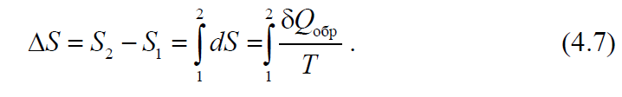

For isothermal process
For reversible processes in an isolated system, δQ_{rev} = 0

Lecture 5
Entropy is a criterion for the direction of the process (constructive condition). Equations for calculating the change in entropy in various processes. Planck's postulate.
Calculation of entropy change in heating or cooling processes
The change in entropy during heating (or cooling) of various substances from temperature T₁ to T₂ at constant volume or constant pressure is determined from equation (4.7). Taking in
attention that 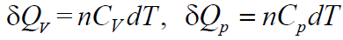 we obtain
and integration under the condition C_{V} = const or C_{p} = const gives
where n is the number of moles of substances.
Taking into account the dependence of heat capacity on temperature
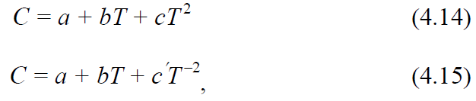
equations (4.10) and (4.11) are written in the form
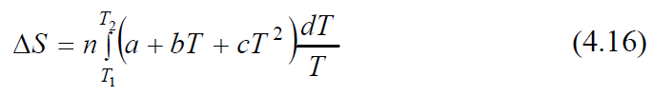
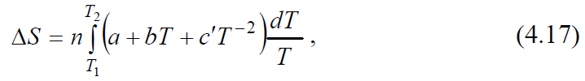
and after integration are presented in the form of the following formulas for calculating ΔS:

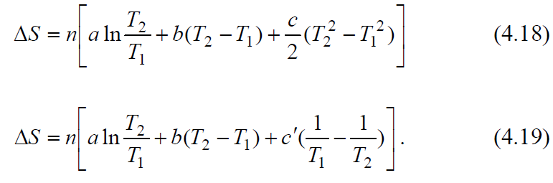
Calculation of entropy during phase transitions
During phase transitions (melting, evaporation, etc.), if the pressure remains constant, the change in entropy (taking into account equation (4.8) and temperature constancy during phase transitions) is calculated by the formula

Where Hф.п. – the heat of the phase transition. For n mol, formula (4.20) rewritten as
In the general case of a reversible process at constant volume, when the change in internal energy is equal to ΔU, or at constant pressure, when the change in enthalpy is equal to ΔН, the change in entropy is:
Change in the entropy of an ideal gas. Diffusion of gases
The change in entropy during the transition of n mol of an ideal gas from one state to another is calculated from the combined equation of the first and second laws of thermodynamics:
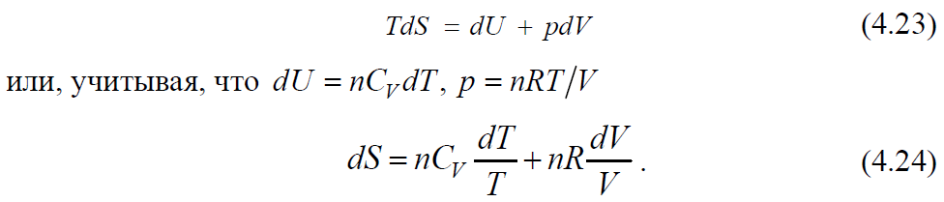
When integrating, assuming the constancy of the specific heat, we have
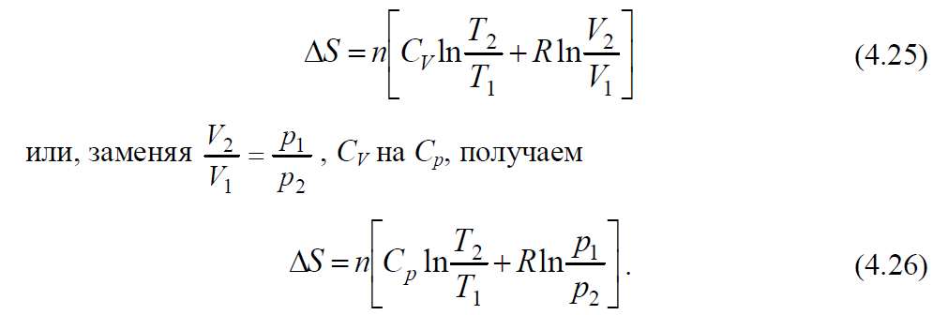
Taking into account the dependence of the heat capacity on temperature, we obtain equations (4.27) and (4.28):
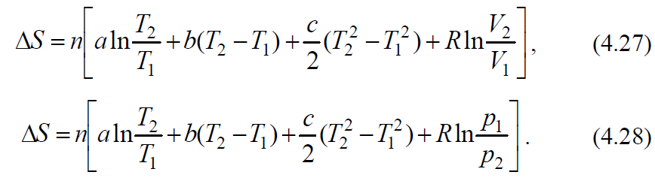
Using the corresponding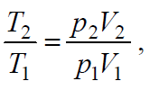can be calculated by the formula

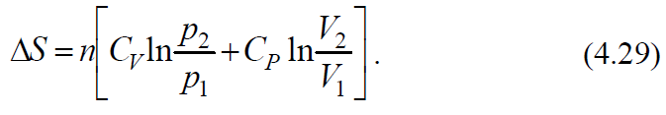
The change in entropy during the adiabatic expansion of an ideal gas is determined by the equation
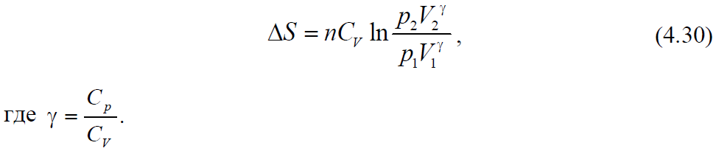
The change in entropy for the processes of isothermal expansion or contraction can be calculated using Maxwell's equations (1):
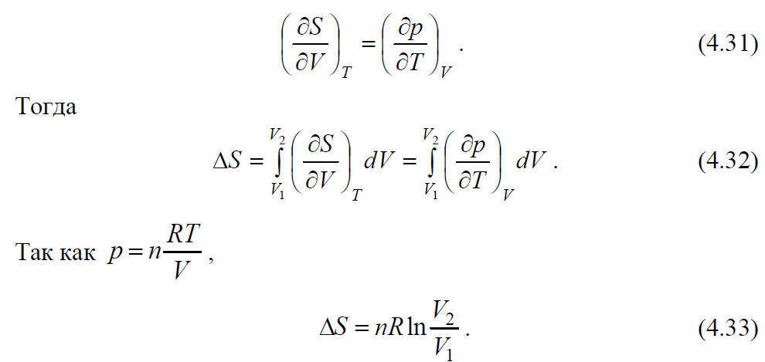
If we use Maxwell's equation (2):
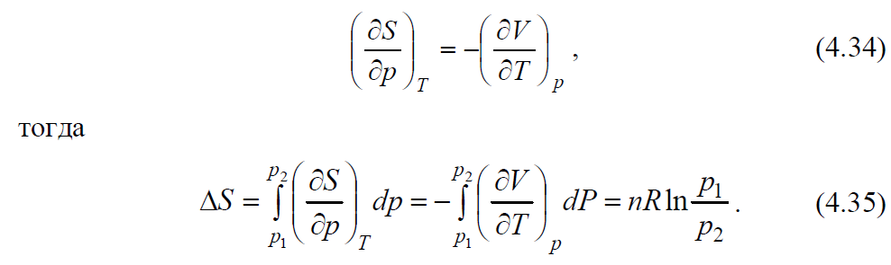
The same result can be obtained if we use the expression for the heat of isothermal reversible expansion of an ideal gas (see Table 3.1)
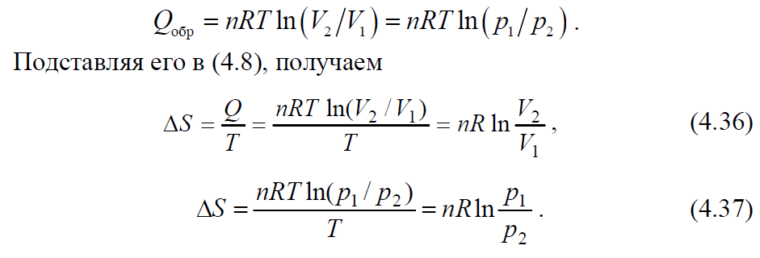
In the process of diffusion during mixing of ideal gases (at p = const and T = const), i.e. in an isobaric-isothermal process, the change in entropy is calculated by the equations
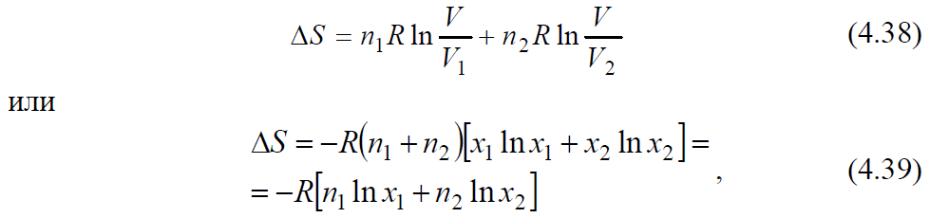
where n₁, n₂ is the number of moles of the first and second gases; х₁, х₂ - molar fractions of both gases; V₁, V₂ - initial volumes of gases; V is the final volume of the gas mixture (V = V₁ + V₂).
The absolute value of entropy
The absolute entropy S ∘ is calculated by the equation
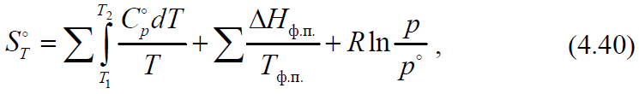
where the first sum expresses the change in entropy in the process of heating a solid, liquid or gaseous substance from one temperature to another, and in the case of a solid, the first temperature is zero degrees Kelvin; the second sum is the change in entropy during phase transitions (melting, evaporation, sublimation);
change in entropy during expansion (compression) of saturated steam from equilibrium pressure to standard pressure 1.013 · 105 Pa.
In expanded form, equation (4.40) has the following form
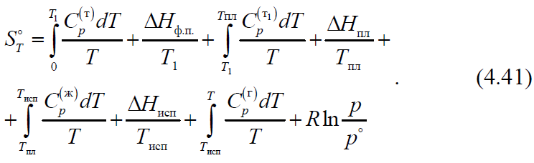
Calculation of the entropy of chemical reactions
For a chemical reaction, the change in entropy ΔrS is calculated by the equation
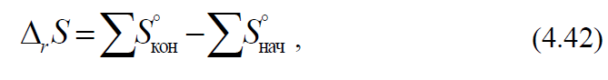
where S∘ is the sum of the absolute entropies of the final and initial substances, taking into account the stoichiometric coefficients of the reaction.
If the change in entropy at temperature T₁ is known, then the change in entropy at temperature T₂ can be found by the formula
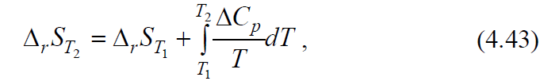
where ΔCp is the difference between the sums of the heat capacities of the reaction products and the initial substances.
In the presence of phase transitions in the temperature range T₁ - T₂ it is necessary to take into account the equation (4.20)
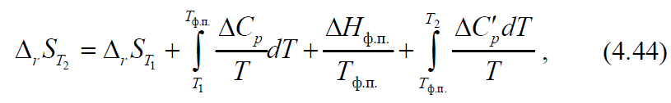
where ΔCp andΔСp
- the difference between the sums of the heat capacities of the reaction products and the initial substances in the temperature range before and after the phase transition.
Calculating the entropy of chemical reactions using electrochemical data
Using electrochemical data, the entropy change can be calculated using the equation
where ∆Н is the thermal effect of a chemical reaction; F is the Faraday number; E is the electromotive force (EMF) of the electrochemical cell in which this reaction takes place; z is the number of electrons participating in the electrode reaction per one reacting particle

Lecture 6
Thermodynamic potentials. Characteristic functions and their natural variables. Comparative characteristics of thermodynamic functions (ΔU, ΔH, ΔS, ΔF, ΔG) as a criterion for the direction of the process.
Thermodynamic potentials and characteristic functions
The combined equation of the first and second laws of thermodynamics - the fundamental Gibbs equation - is the basis of the mathematical apparatus of thermodynamics. For reversible processes, it is written in the form
where Хk are other coordinates of the state, except for S and V, and Рk are generalized forces except for Т and p. Comparison of equation (4.46) with the expression for the total differential of the internal energy
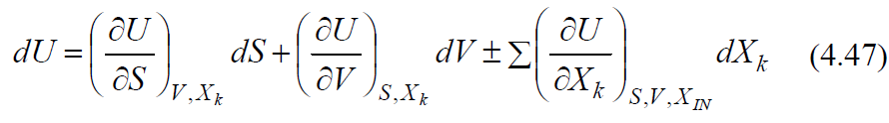
shows that all generalized forces are partial derivatives of the function U with respect to the coordinates Xk
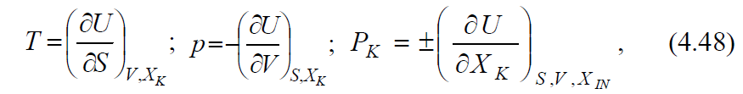
where the index IN means the constancy of all coordinates XI, except for Xk

Lecture 7
Chemical potential, its relationship with thermodynamic functions and composition of the system. Chemical potential of a component in ideal and real solutions. Activity, activity coefficient.
When solving specific problems, equations (4.46) - (4.47) usually turn out to be inconvenient, since entropy, which is inaccessible for experimental determination, has to be considered as an independent variable. Therefore, the fundamental equation (4.46) is transformed to other variables using the Legendre method known in mathematics. Since РkХk is a state function, any auxiliary function of the form Ф = U - ΣРkХk is also a state function. The substitution H = U + pV leads to the replacement of V by p and we have the equation
The substitution F = U - TS leads to the replacement of S by T. This determines the Helmholtz energy F and its differential
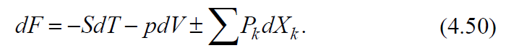

Lecture 8
Homogeneous equilibrium, its features and conditions. Isothermal equations of chemical reactions and directions of processes for various homogeneous systems. The law of mass interaction and the equilibrium constant of a chemical reaction.
The replacement of S by T and, at the same time, V by p is carried out by the substitution G = U - TS + pV, which leads to the consideration of the Gibbs energy G as another function of the state
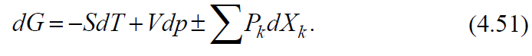
Each of the equations (4.49) - (4.51) is the combined equation of both principles of thermodynamics, transformed to other independent variables.
For closed systems in which only mechanical work is performed, equations (4.46), (4.49) - (4.51) have the form
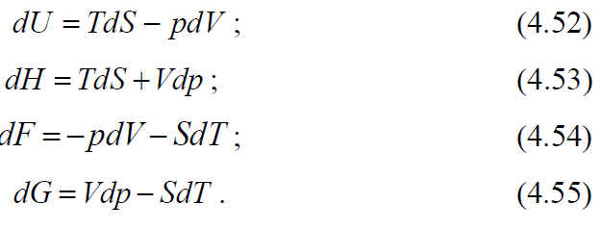

Lecture 9
Temperature dependence of the equilibrium constant. Isobaric and isochoric Van't Hoff equations.
The most complete information about all properties of the system is given by each of these functions, if it is defined explicitly in terms of "Natural" - specified in brackets - variables:
These functions are characteristic. A function in thermodynamics is called characteristic if its values ​​and the values ​​of its derivatives are sufficient for a complete description of the system, that is, to find the numerical value of any quantity of interest to us, to establish the relationship between the measured quantities. Of the many characteristic functions, five — U, H, F, G, and S — have acquired the greatest significance in thermodynamics, and in specific thermodynamic calculations, two — Helmholtz energy and Gibbs energy, since their natural variables are most convenient for chemistry. Another (outdated) name for these functions is isochoric-isothermal and isobaric-isothermal potentials.
Various properties of the system are expressed in an explicit form through the derivatives of different orders of characteristic functions. From equations (4.52) - (4.56) we will have:
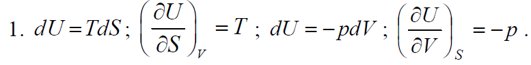
If the obtained derivatives are differentiated again, but each with respect to a different natural variable of the given function, mixed second derivatives are obtained, the equating of which makes it possible to obtain Maxwell's equation
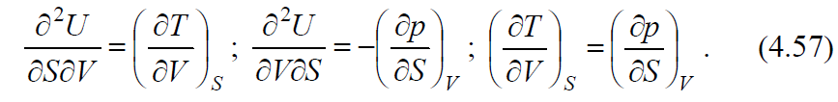

Lecture 10
Phase, components, constituent. Heterogeneous chemical systems, equilibrium conditions in them. Gibbs Phase Rule. Clapeyron-Clausius equation. Description of the state of the water diagram by the Clapeyron-Clausius equation and the Gibbs phase rule. Phase transitions of types 1 and 2, their features.
Similarly, we will carry out mathematical operations with respect to other characteristic functions:
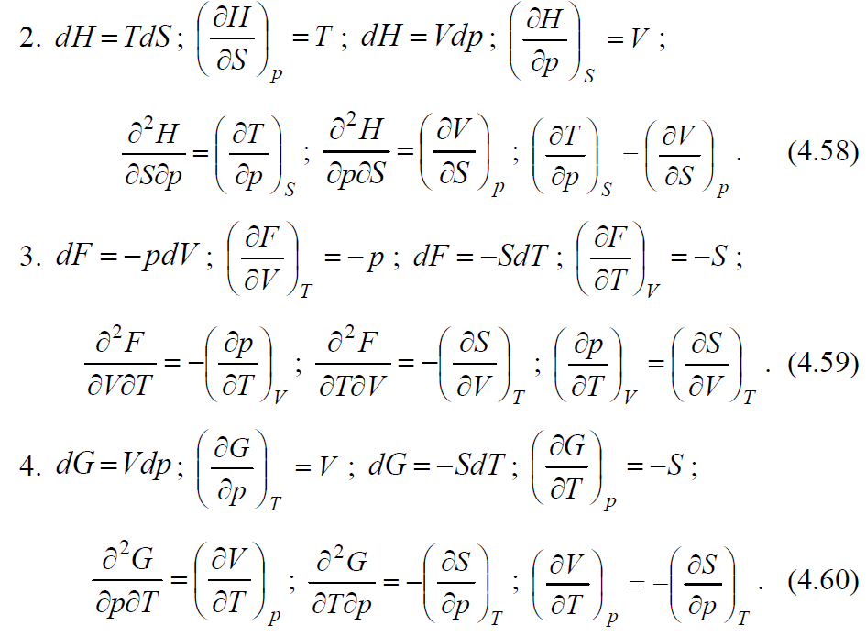
Using the described transformations, we obtain the Maxwell equations:
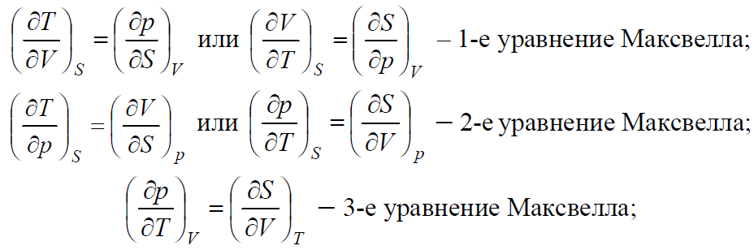
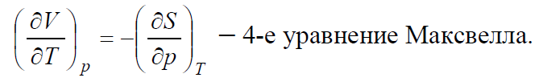
Lecture 11
Melting diagram of a two-component system: one-eutectic systems, systems in which components interact chemically (forming compounds with congruent and incongruent melting points). Solid solutions, their formation by penetration and displacement. Melting diagram of solid solutions. Gibbs-Rosebohm Rules I and II.
All four obtained Maxwell's equations are convenient in that the derivatives of entropy, which are difficult to obtain, are replaced by derivatives of pressure or volume from temperature. Maxwell's equations, especially the last two, find various applications in physical chemistry.
If the system is open and exchanges matter and energy with the environment (a chemical reaction occurs in the system), then it is necessary to take into account the dependence of thermodynamic potentials on the amount of substances ni. Then equation (4.47) is represented in the form
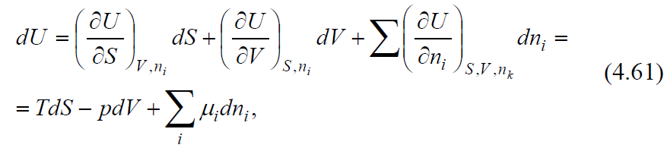
where ni is the amount of substance of the i-th component, and the symbol nk means the constancy of all nk, except for ni.
The internal energy in this case is a function of the volume, entropy and masses of the components and is written as 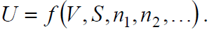
Similarly, for other potentials, we obtain the equations
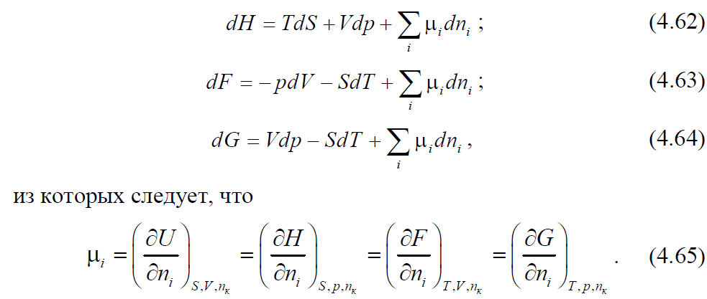

Lecture 12
Solubility of two and three liquids in each other. Methods for displaying the composition of a three-component system. Tarasenkov's rule. Crisis melting points. Extraction.
The function μ is called the chemical potential, which characterizes the increment of the thermodynamic potential when the amount of a given substance changes with fixed natural variables and unchanged amounts of other substances.
If any other work related to mass transfer is performed in the system, then the concept of “total potential” is introduced. These include, for example, the electrochemical potential of the i-th component
where 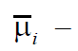F, (4.66) - full potential; F - Faraday number, φ - potential difference
In the general case, the total potentials are derivatives of the functions U, H, F, G with respect to independent coordinates.
The considered thermodynamic functions and potentials make it possible, under certain conditions, to predict the direction of the thermodynamic process. General conditions of thermodynamic equilibrium and spontaneous course of the process are presented in table. 4.2.

Lecture 13
Thermodynamic properties of ideal liquid solutions. Real solutions. Raoult's law. Thermodynamic substantiation of the linear dependence of the total and partial vapor pressure on the composition of the system for ideal systems.

General conditions for the equilibrium of thermodynamic systems
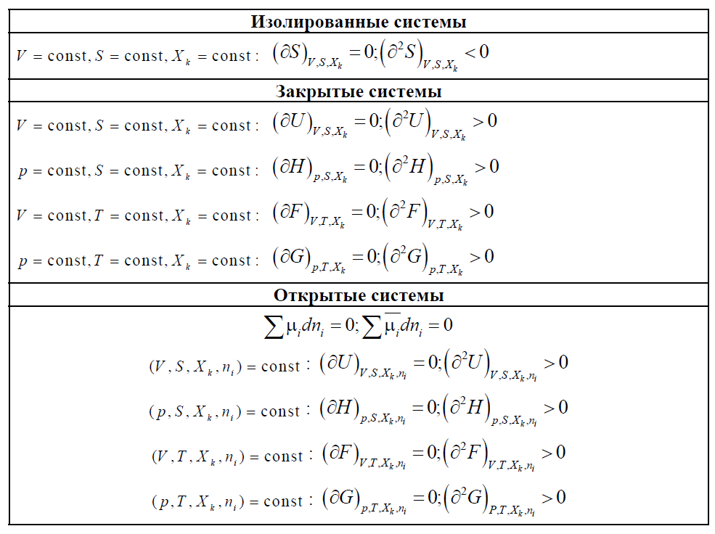
Lecture 14
Boiling point (vapor pressure) - composition (t, P - x) diagrams. Gibbs-Konovalov laws I and II.
The decrease in the Helmholtz energy in any process at T = const, V = const is equal to the maximum mechanical work that the system can perform in this process

Thus, the energy F is equal to that part of the internal energy (U = F + TS) that can turn into work.
Similarly, the decrease in the Gibbs energy in any process at T = const, p = const is equal to the maximum useful (ie, non-mechanical) work that the system can perform in this process

Lecture 15
Ebuliometry. Cryometry. Determination of the molecular weight and molecular state of the solute from cryometric or ebuliometric data. Isotonic Van't Hoff coefficient.
The dependence of the Helmholtz (Gibbs) energy on the volume (pressure) follows from the basic equation of thermodynamics (4.54), (4.55):
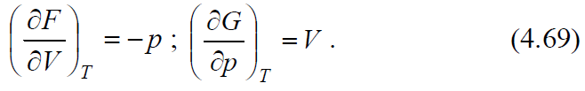
The temperature dependence of these functions can also be described using the same equations:
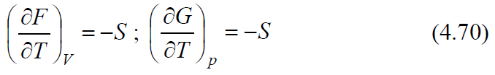
or using the Gibbs – Helmholtz equation
